

**ATA Carnets – Quick Guide to Carnet Disputes and Claims**

**ATA Carnet** is a temporary admission document. This means that all goods temporarily imported into Carnet countries must be re-exported and repatriated within the validity of the document.

**Carnet Holder** is a company or an individual, shown in Box A of the ATA Carnet. This entity is legally responsible for payment of Customs charges if the document has not been used correctly. **Note** – that the Holder is responsible regardless of whether the Carnet has been handled by an agent or by the Holder).

**Dispute** is a formal process which is initiated by the foreign Customs as a result of the Carnet not being endorsed on re-exportation; transit has not been closed; there is a discrepancy between items imported and re-exported, or if the time limit for re-export or transit has been exceeded.

**Claim** is a request for payment arising from an unresolved dispute. Carnet Holder is responsible for payment of the claim. **Note -** security lodged against the Carnet, at the time of issue, is to **protect the Chamber** in case the Holder is unable to pay the charges. Issuing Chamber or its insurers may take legal action against the Holder in the event of the claim remaining unpaid!

1. TIMELINES INVOLVED IN THE DISPUTE / CLAIM PROCESS

Carnet Holder has 6 months to answer the claim. If the admissible evidence has not been provided by the due date, foreign Customs will calculate charges that the **Holder is legally obliged to pay**:

2. WHAT CAN I DO TO RESOLVE THE DISPUTE (ADMISSIBLE PROOF)

Claiming Customs will usually only accept Customs endorsed evidence. This can be as follows:

**Admissible evidence** (this is usually accepted provided transactions are dated within the validity of the Carnet)

* Endorsed Carnet (re-export from claiming country or re-import into UK on the same Carnet)
* Certificate of Location confirming when the goods were reimported (before Carnet expired)
* Customs entry showing that duty was paid or goods were transferred to another procedure

**Alternative evidence** (this type of evidence is rarely accepted and is only used in absence of admissible evidence)

* Proof of the same goods being used on another ATA Carnet (but only if transaction happened before the Carnet under the claim expired)
* Police Report for stolen goods (**Note**- stolen items are usually treated as permanent import)
* Shipping document (CMR / AWB/ BL) showing goods were transported

3. HOW CAN I CHECK IF MY CARNET HAS BEEN USED CORRECTLY

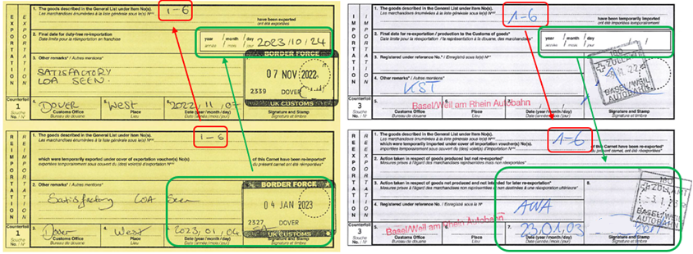

**TIME LIMIT FOR REEXPORTATION**

**Goods must be re-exported by this date!**

OUT IN

IN OUT

Goods were re-exported from

Goods were reimported into UK the country of temporary admission

4. WHAT SHOULD I DO IF THE CARNET WAS NOT STAMPED BACK INTO UK

Contact the National Carnet Unit and request a Certificate of Location:

Email: [atacarnetunit@hmrc.gov.uk](mailto:atacarnetunit@hmrc.gov.uk) / Telephone: 0300 322 7064

5. how CAN I PROTECT MYSELF FROM A CLAIM

* Ensure all re-exports and transits are completed within the time limit imposed by Customs
* Ensure correct items are declared at each stage of the journey (Section F of the Voucher)
* When you finish using the Carnet, scan the Counterfoils (in colour) and keep on file
* Send the original Carnet to the Issuing Chamber as soon as you have finished using it (Special Post or in Person)
* Obtain a Certificate of Location if the Carnet has not been endorsed on return to UK

6. where can i get further information on ata carnets

Contact Thames Valley Chamber: [carnet@tvchamber.co.uk](mailto:carnet@tvchamber.co.uk) or [UKNATACO](http://www.uknataco.co.uk)